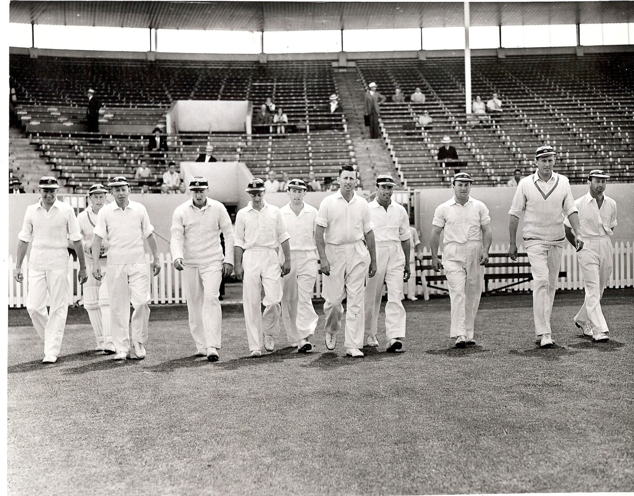

**Canterbury Lancaster Park 28 December 1960**

**From Left:** **AG Duckmanton, JT Ward, JW Kiddey, RC Motz, BA Bolton, GT Dowling, ME Chapple (captain),**

**SC Guillen, K Thompson, AR MacGibbon, PGZ Harris**

**Wellington 221 and 140. Canterbury 241 and 124/5. Canterbury won by five wickets**